1204 has serial and parallel functions, supporting up to 4 strings in series, all of which use automatic address allocation.
Series mode
The specific connection diagram is as follows:
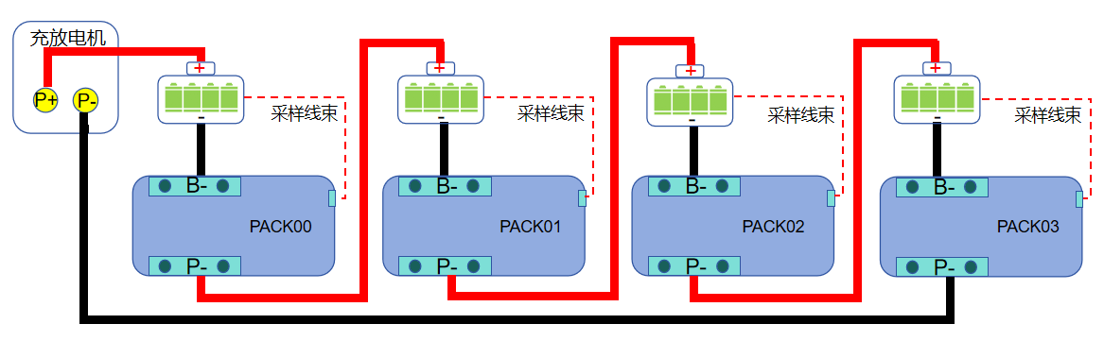
1. Connect the battery and BMS according to the serial diagram;
2. Connect to the upper computer and open 'Upload Parameters'. 1204 has two 485 communication channels and one CAN communication channel. Two 485 channels including RS485 (2A, 3B) with a baud rate of 9600bps, RM485（4A、5B）， The baud rate is 19200bps, and it can connect to the upper computer and modify parameters;
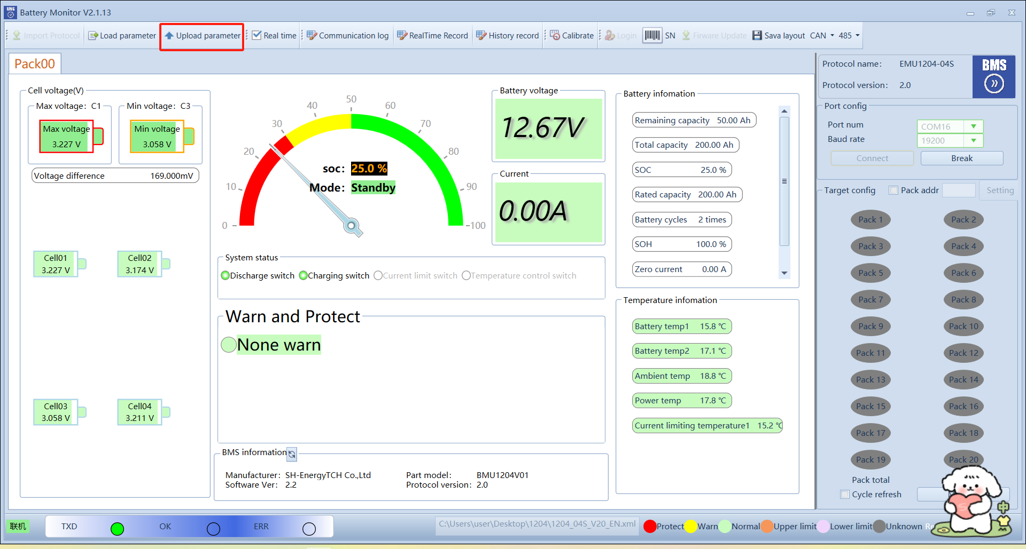
3.On the parameter management interface, open "Enable Series Mode" (you can only open the host, and the host will decide the serial parallel);
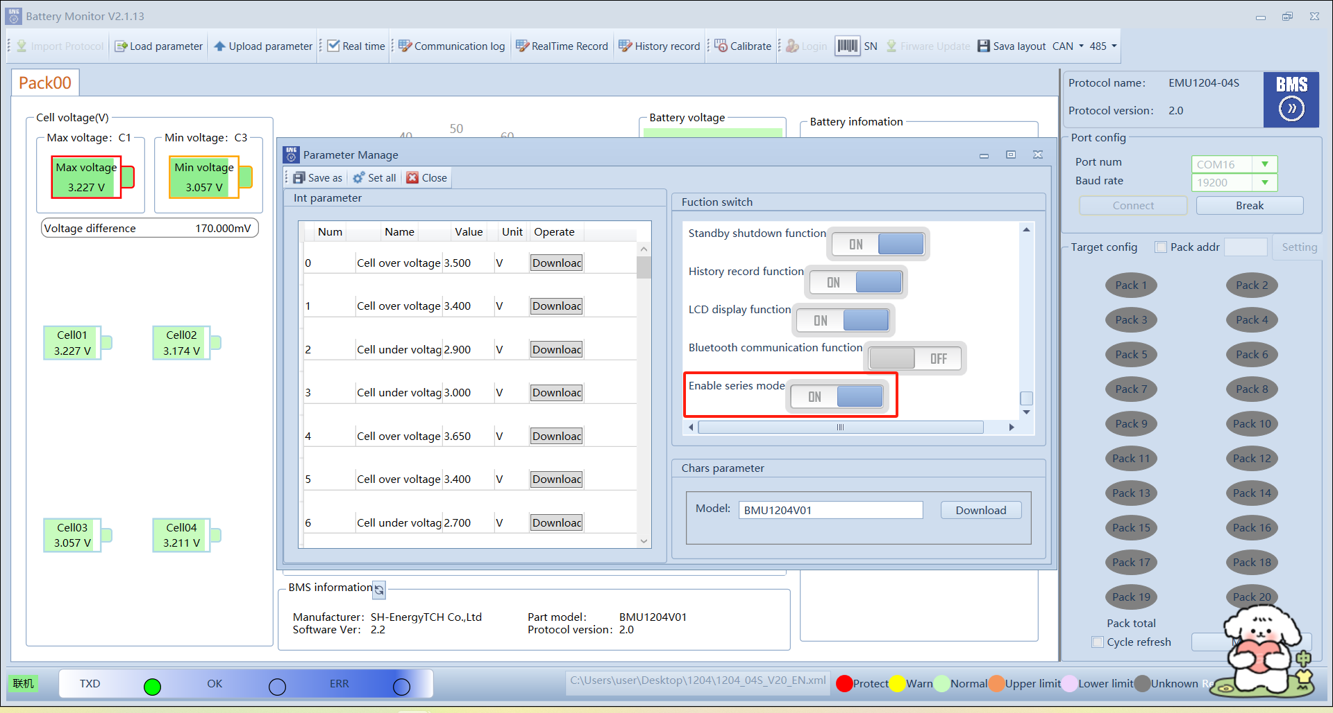
4.Finally, click "Set all" to complete the serial mode setting.
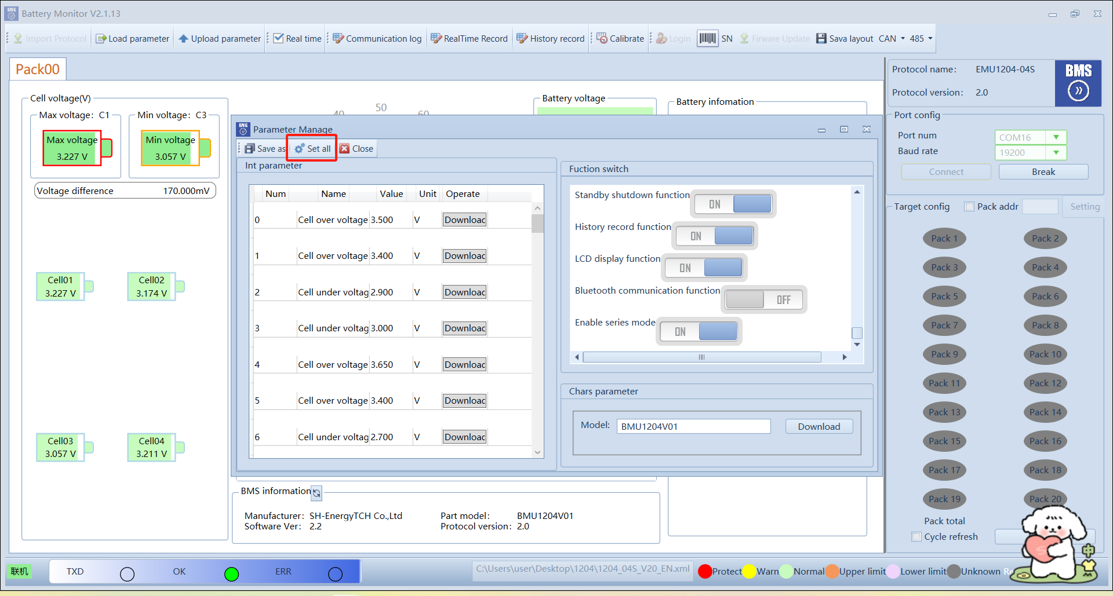
Parallel mode
The specific connection diagram is as follows:
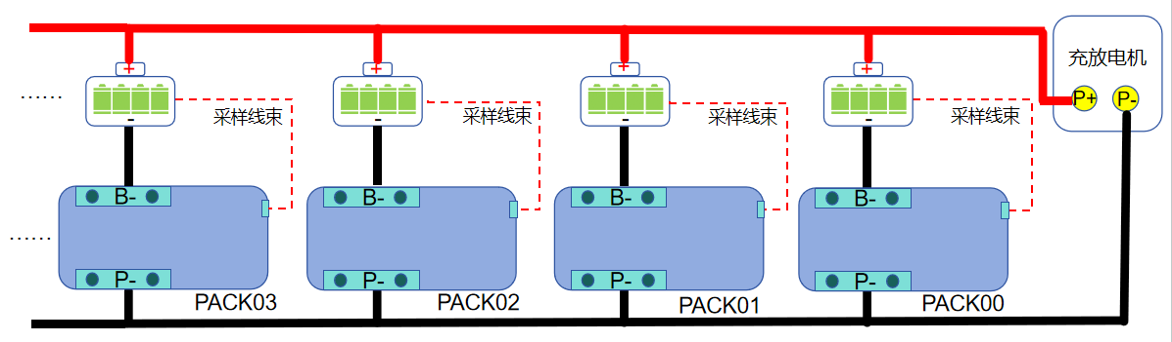
1. Connect the battery and BMS according to the serial diagram;
2. Connect to the upper computer and open 'Upload Parameters'. 1204 has two 485 communication channels and one CAN communication channel. Two 485 channels including RS485 (2A, 3B) with a baud rate of 9600bps, RM485（4A、5B）， The baud rate is 19200bps, and it can connect to the upper computer and modify parameters;
3. On the parameter management interface, turn off "Enable Series Mode";
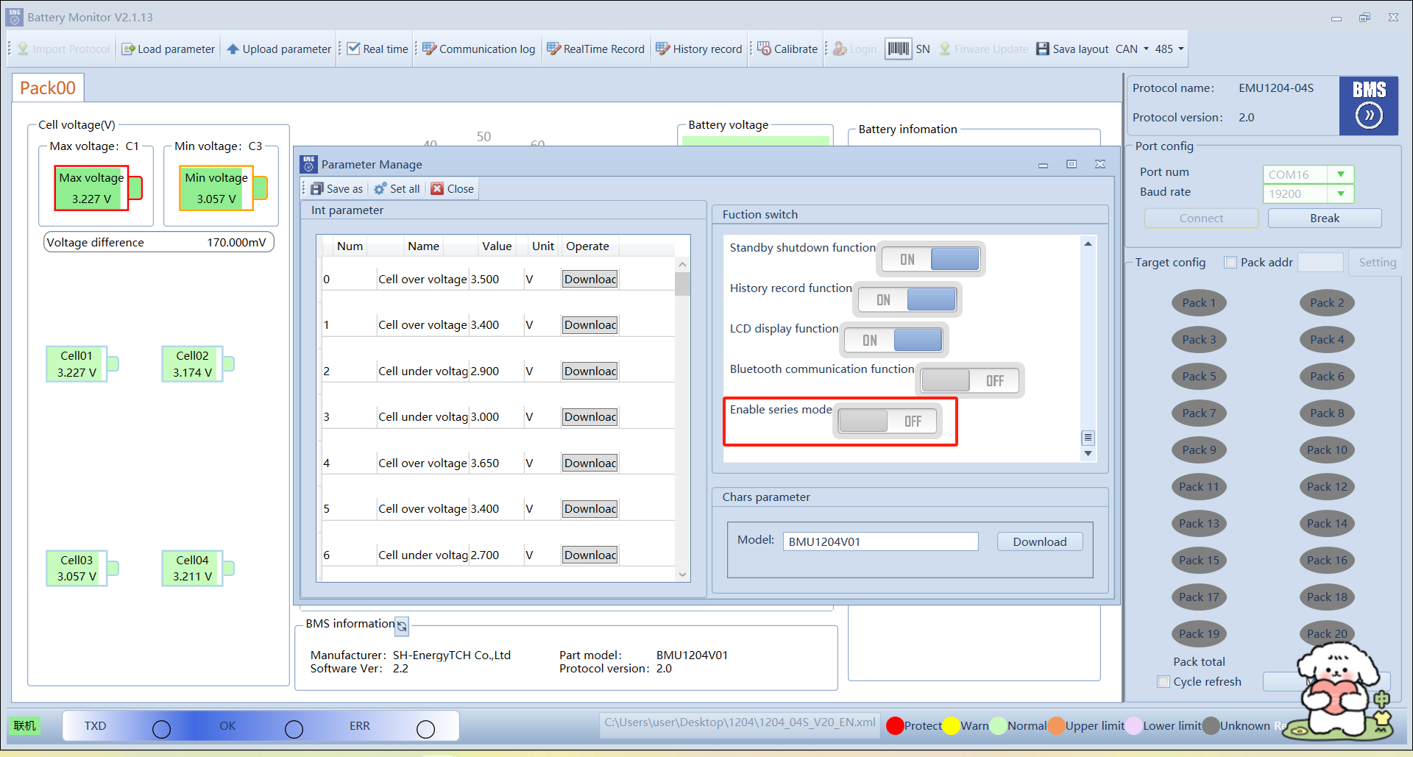
- Finally, click "Set all" to complete the parallel mode setting.
